**Supplemental material for the paper ‘Homicides in Mexico increased inequality of lifespans and slowed down life expectancy gains in 2005-2015‘**

**Authors:** José Manuel Aburtoa & Hiram Beltrán-Sánchezb

**Author affiliations:**

a Department of Public Health, Unit of Biodemography, University of Southern Denmark, Odense 5000, Denmark.

b Department of Community Health Sciences at the Fielding School of Public Health and California Center for Population Research, University of California, Los Angeles, California, USA.

**Corresponding author:**

José Manuel Aburto

Email: [jmaburto@health.sdu.dk](mailto:jmaburto@health.sdu.dk)

Tel. number: +45 65 50 94 16

Affiliation: Department of Public Health, Unit of Biodemography, University of Southern Denmark.

Address: J.B. Winsløws Vej 9. DK-5000 Odense C, Denmark

**Keywords:** violence, lifespan variation, avoidable mortality, causes of death, public health.

**Abstract**

**Background** Mexico experienced an unprecedented rise of violence after 2005. The net effect of this rise on lifespan inequality and life expectancy for the young population in the last decade is unknown.We quantify the effect of rising homicides on lifespan inequality and average lifespan from 2005 to 2015.

**Methods** Life expectancy and lifespan inequality conditional on surviving to age 15, as measured by years of life lost, with age- and cause-specific contributions to the changes between 1995 and 2015 were calculated. We analysed medically amenable conditions, diabetes, ischemic heart diseases, traffic accidents and homicides by state and sex.

**Results** Mexican male life expectancy at age 15 increased more than twice in 1995-2005 (1.17 years) than in 2005-2015 (0.55 years). Lifespan inequality decreased by more than half a year for males in 1995-2005 (from 14.31 to 13.77), while in 2005-2015, the reduction was about four times smaller. Homicides between ages 15-49 had the largest effect on slowing down male life expectancy and lifespan inequality in 2005-2015. At the state level, some states experienced reductions in life expectancy in 2005-2015 particularly in the North. In the same period five states showed a large increase in lifespan inequality.

**Conclusions** After ten years of the unexpected increase of violence in Mexico, the country has not been able to reduce the levels homicides to those prior to 2005. Thus, life expectancy slowed down and inequality of lifespans increased among young Mexican males.

**Lifespan inequality indicator**

In lifetable notation, is defined as:

where and are the survival function, the force of mortality, life expectancy, the age at death distribution at age , and the open-aged interval, respectively.

**Decomposition method summary**

The decomposition method used in this paper is based on the line integral model (Horiuchi et al 2008). Suppose (e.g. or life expectancy) is a differentiable function of covariates (e.g. each age-cause specific mortality rate) denoted by the vector . Assume that and depend on the underlying dimension , which is time in this case, and that we have observations available in two time points and . Assuming that is a differentiable function of between and , the difference in between and can be expressed as follows:

where is the total change in (e.g. or life expectancy) produced by changes in the -th covariate, . The 's in equation (2) were computed with numerical integration following the algorithm suggested by Horiuchi et al (2008). This method has the advantage of assuming that covariates change gradually along the time dimension

**Code and data to reproduce results**

Available at <https://goo.gl/tQV6fL>.

**Shinny app for sensitivity and state specific analysis**

Results with starting age 0, available at <https://goo.gl/n9XuDy>

Results with starting age 15, available at <https://demographs.shinyapps.io/LVMx_15_App/>

**Supplemental figures. All figures are own calculations based on CONAPO (2017) and INEGI (2017) data.**

**Figure S1. Age-cause specific contributions to the changes in national life expectancy at age 15 for females. Panel A refers to 1995-2005 and panel B to 2005-2015. Note: Numbers in boxes are age-specific contributions.**

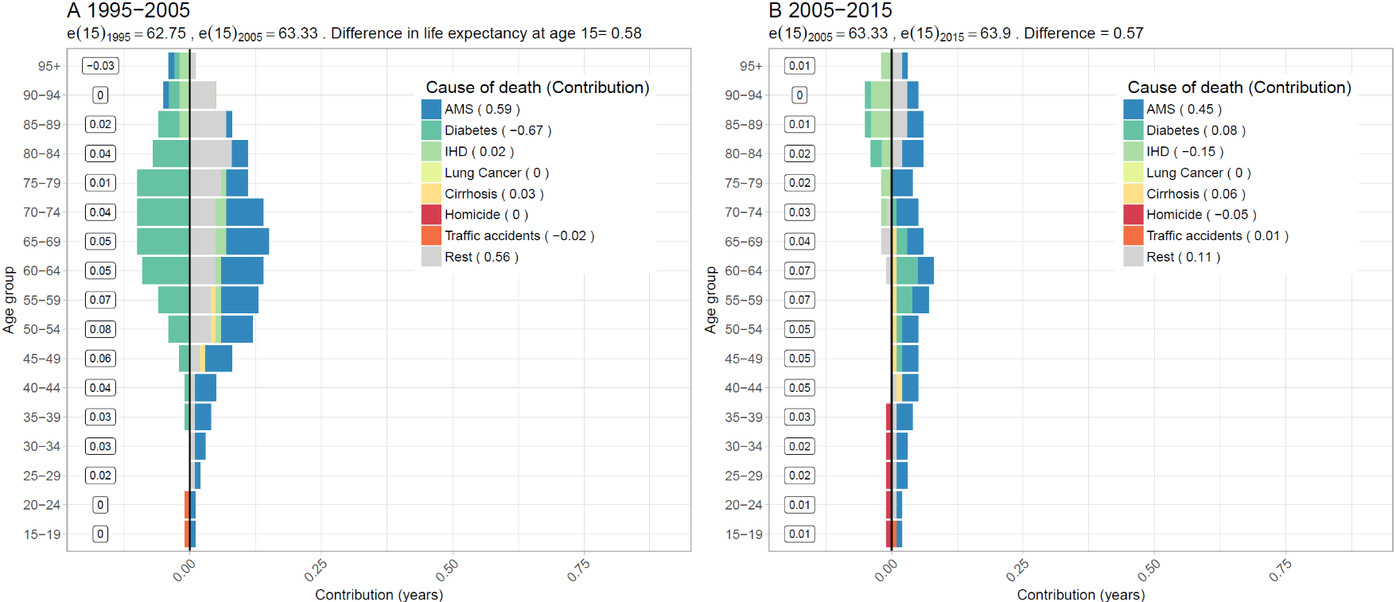

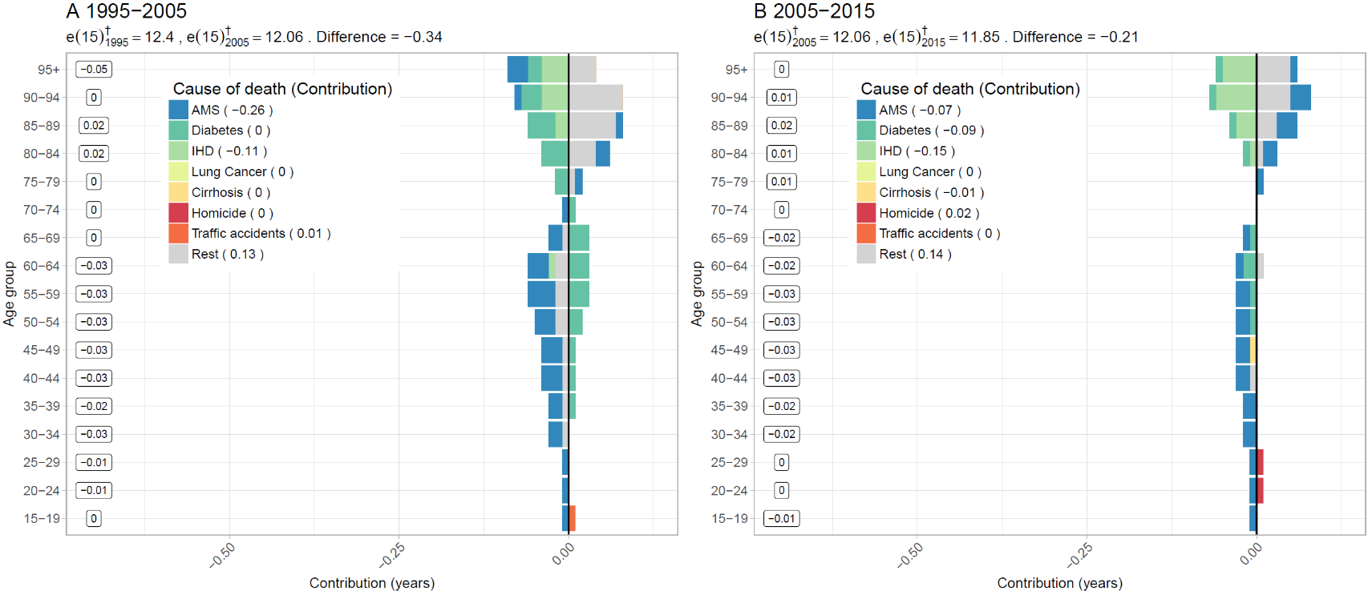**Figure S2. Age-cause specific contributions to the changes in national lifespan variation at age 15 () for females. Panel A refers to 1995-2005 and panel B to 2005-2015. Note: Numbers in boxes are age-specific contributions**

**Figure S3. Changes in female life expectancy (**e15**) (panel A) and female lifespan variation at age 15 () (panel 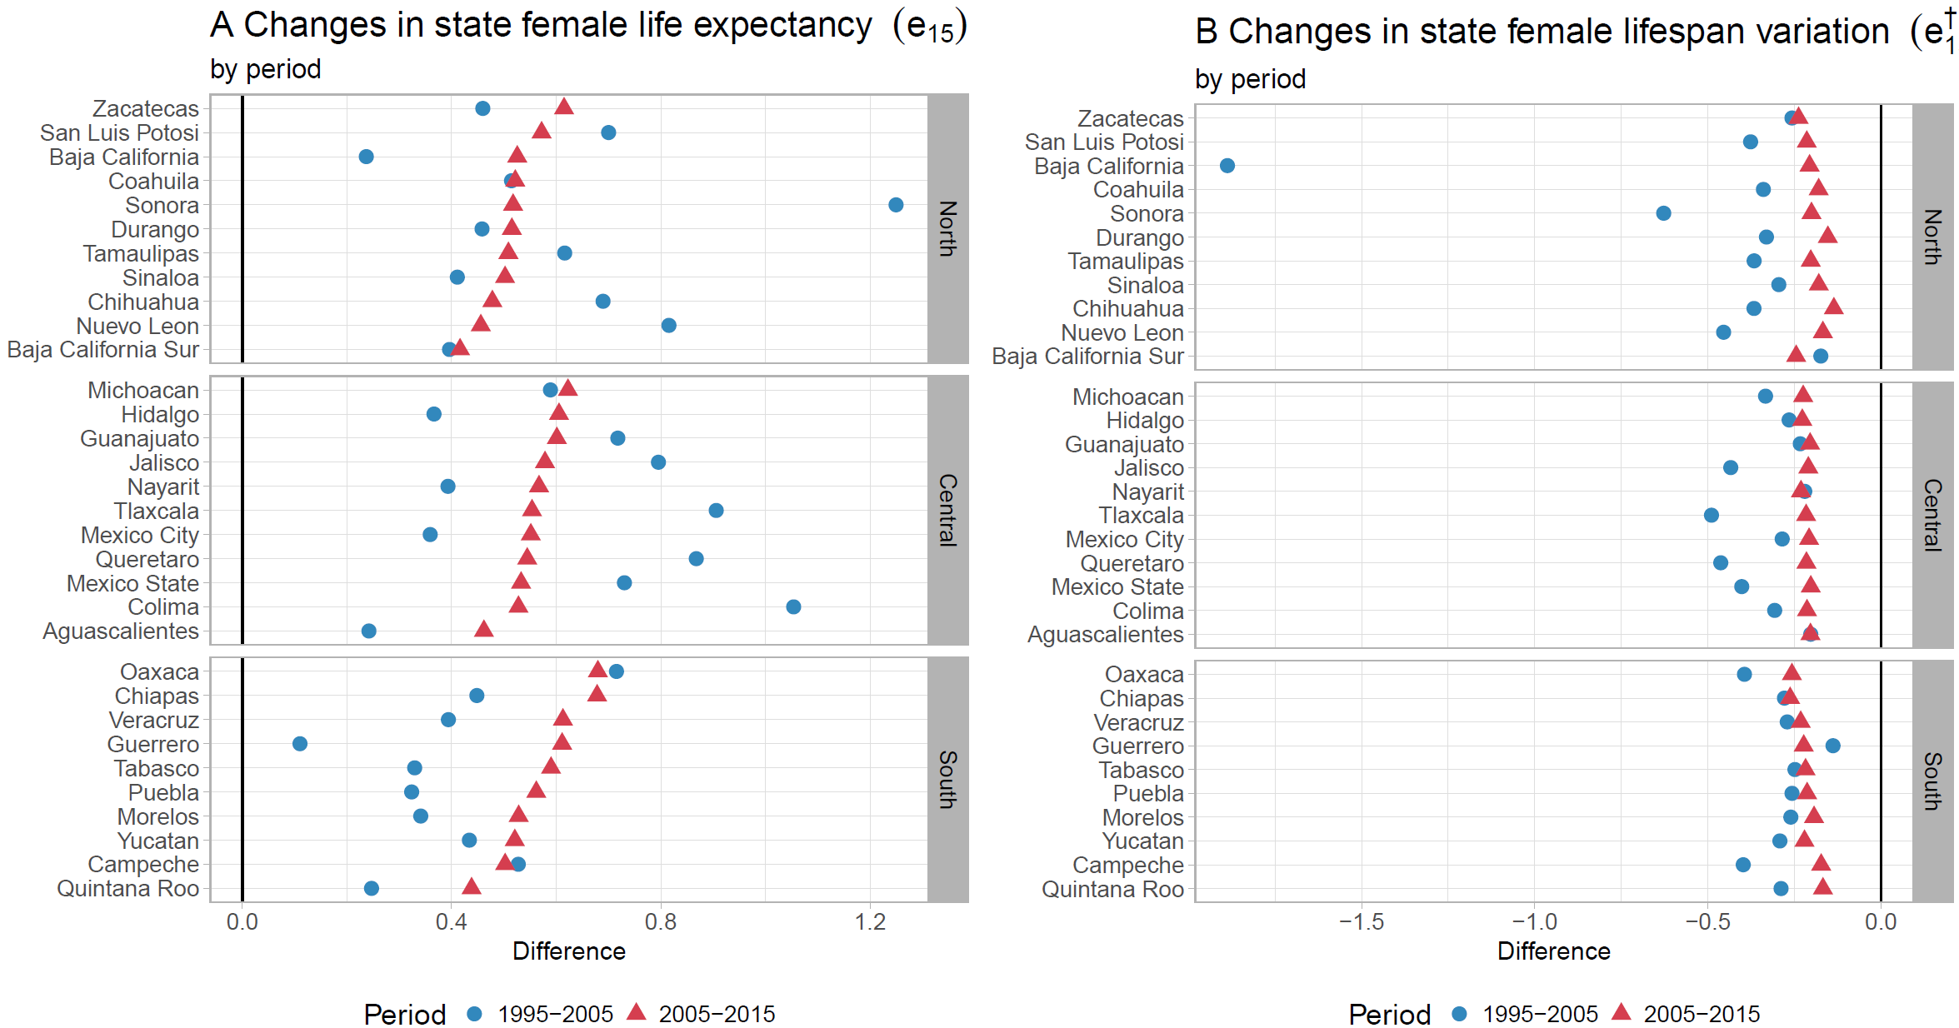B) by state for the periods 1995-2005 and 2005-2015**

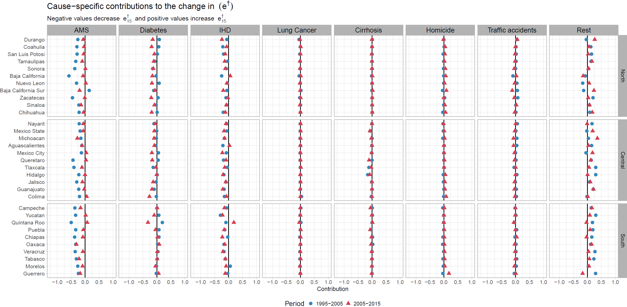**Figure S4. Cause-specific contributions to changes in female lifespan variation at age 15 () by state for the periods 1995-2005 and 2005-2015.**

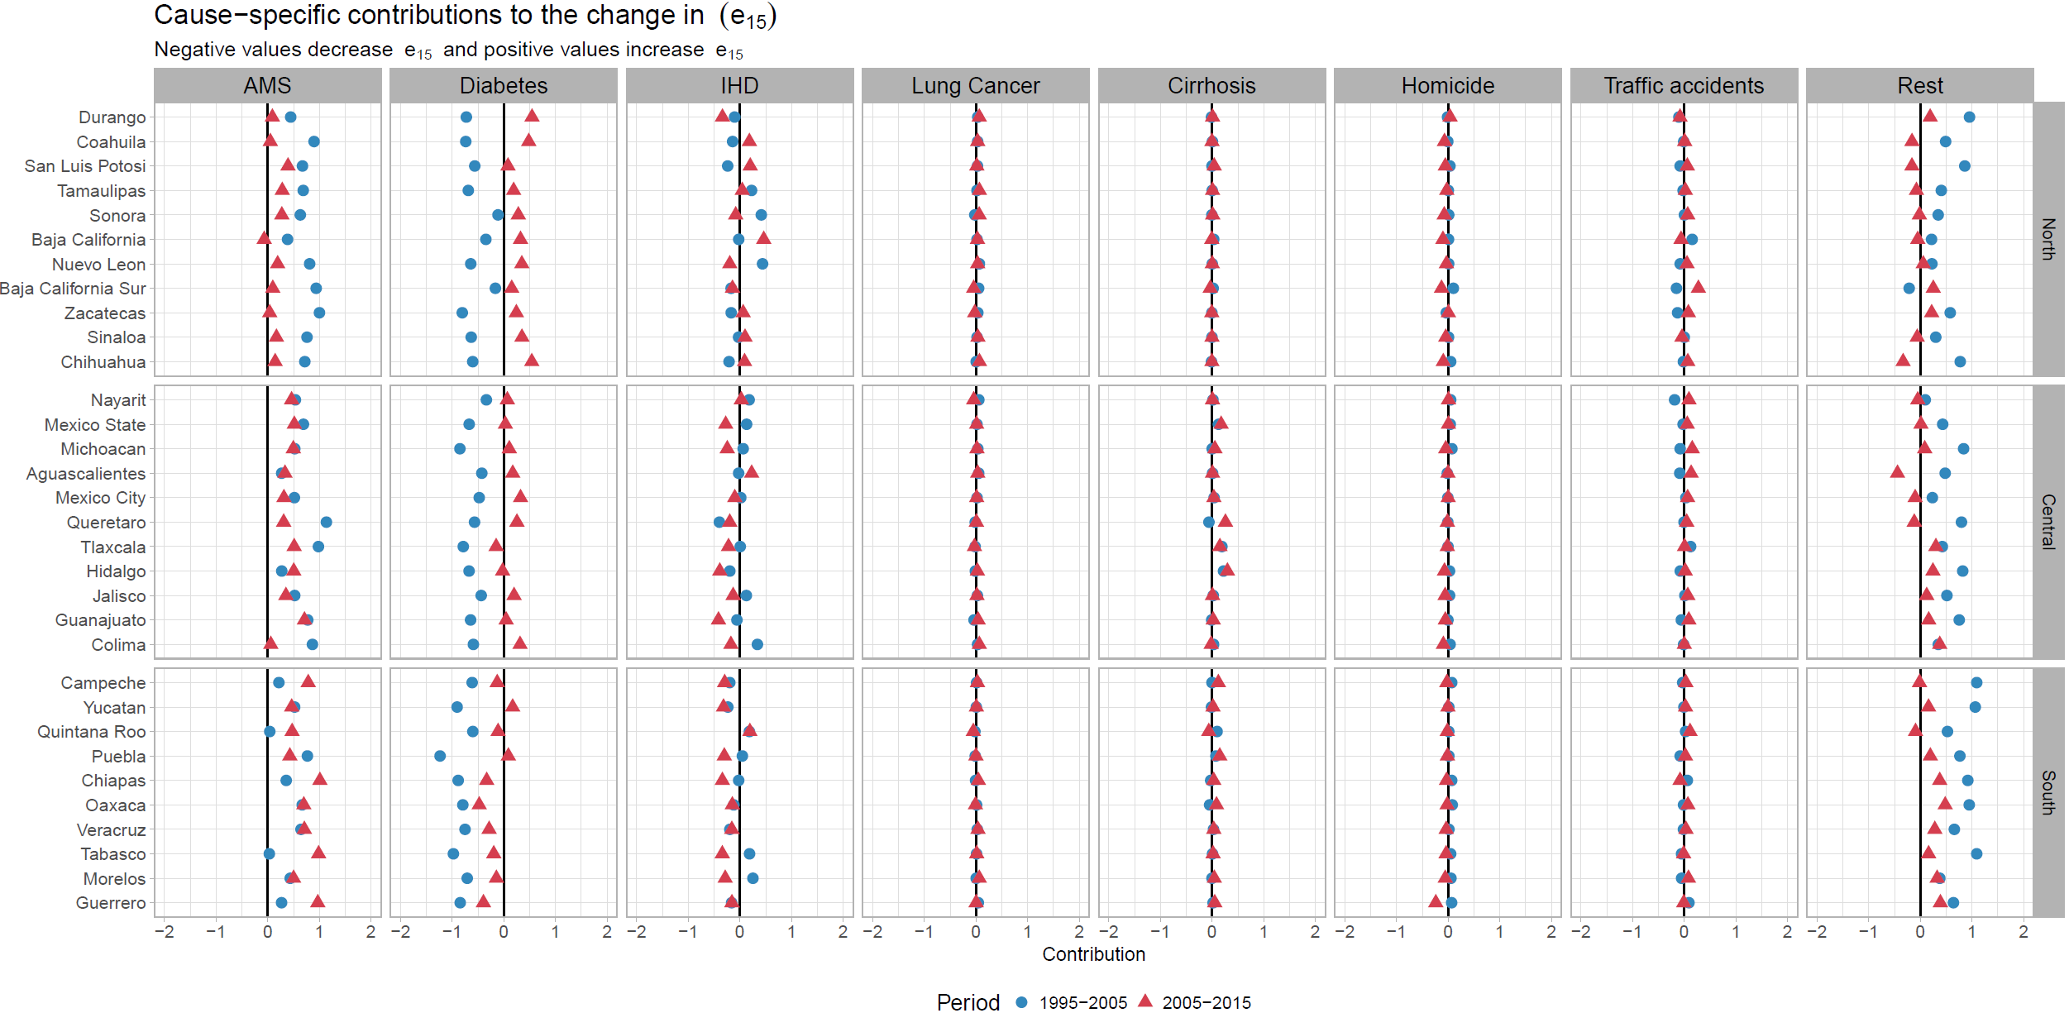**Figure S5. Cause-specific contributions to changes in female life expectancy at age 15 () by state for the periods 1995-2005 and 2005-2015.**

**Figure S6. Cause-specific contributions to changes in male lifespan variation at age 15 () by state for the periods 1995-2005 and 2005-2015.**

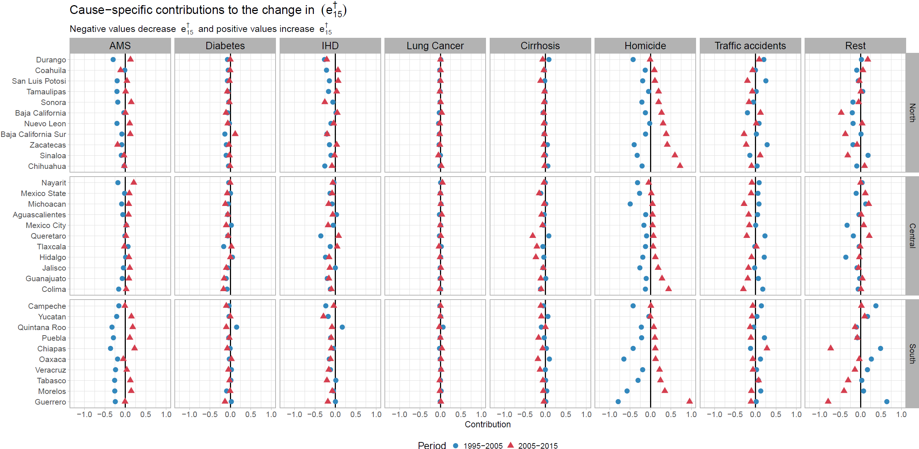

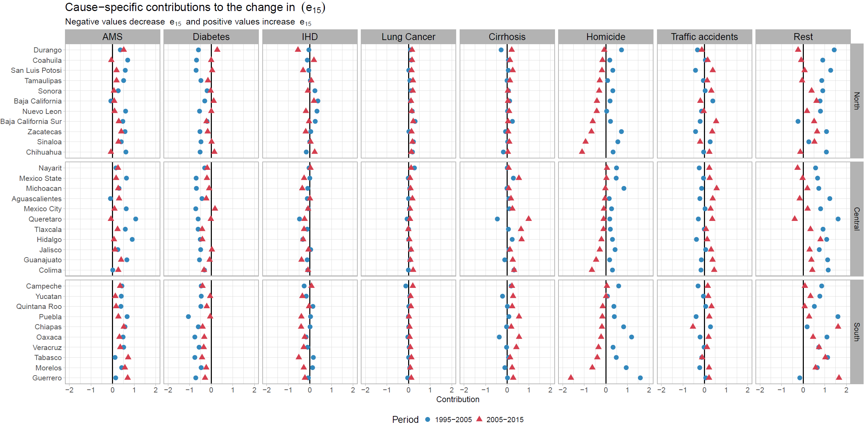**Figure S7. Cause-specific contributions to changes in male life expectancy at age 15 () by state for the periods 1995-2005 and 2005-2015.**

**References**

CONAPO. (2017). Mexican Population Council: Population estimates. Retrieved from <https://datos.gob.mx/busca/dataset/activity/proyecciones-de-la-poblacion-de-mexico>

INEGI. (2017). National Institute of Statistics: Micro-data files on mortality data 1995-2015. Retrieved from <http://www.beta.inegi.org.mx/proyectos/registros/vitales/mortalidad/default.html>